Name:Paul P. Aquino BSIT-305

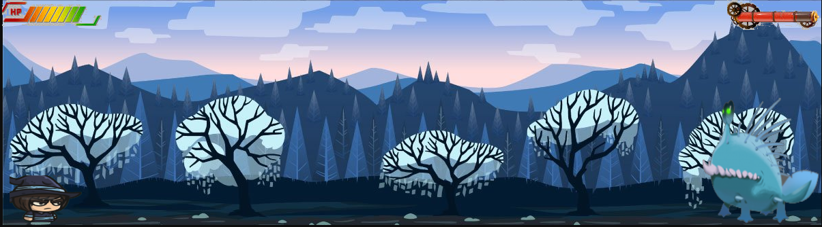

GameTitle:DEMONTIDE

Target: 5-10 Years old

Ratings:10+ Pegi E

Ganre: ADVANTURE,Role

NUMBER OF PLAYED: SINGLE PLAYER

PLATFORM:ANDROID @ PC

GamePlay:2d

Story:Archer,Barbarian,mage want to kill a monster and we want a freedom…